Connected Personal Wellness

TheCoders97

- Use Case Overview
Fitness from ECG
By using this device we can check the ECG result which tells us about our fitness level.
- Use Case Description
The device will be implemented to check and analyze our fitness level by a series of algorithmic constraints by taking the ECG readings.
Abstract:
- ECG principle
In the real world we take pulse readings to check the heartbeats or cardiovascular issues. Depending on that we can find pressure of heart i.e. blood pressure.
- Machine Learning (Supervised Learning)
It will be basically employed to learn from the dataset we fed into it to give the most probable and accurate results for the check. It is the base where the probability and algorithms on which the results would be calculated are implemented.
Scope :
It has a wide sense of implementation and uses from rural to urban areas as it’ll be able to generate a spontaneous result in a short span of time and also at a considerate cheap cost. Also the heart related issues can be learned through the same.

Diagram / Pictures (if any) :
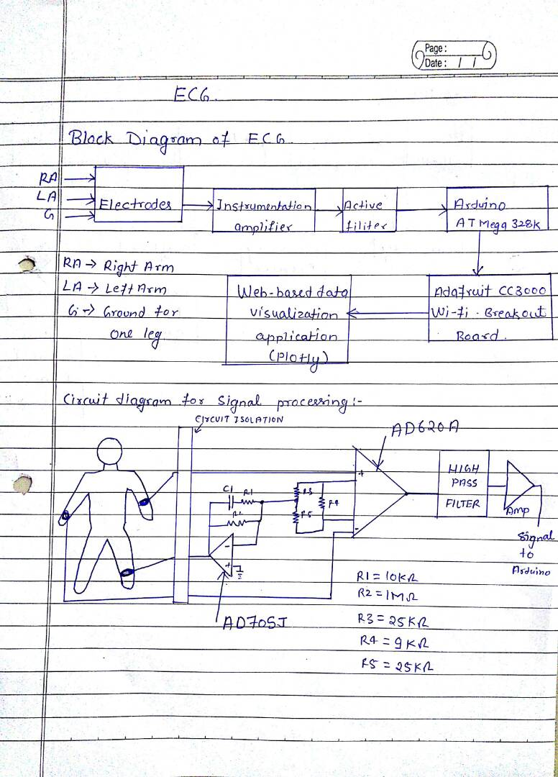
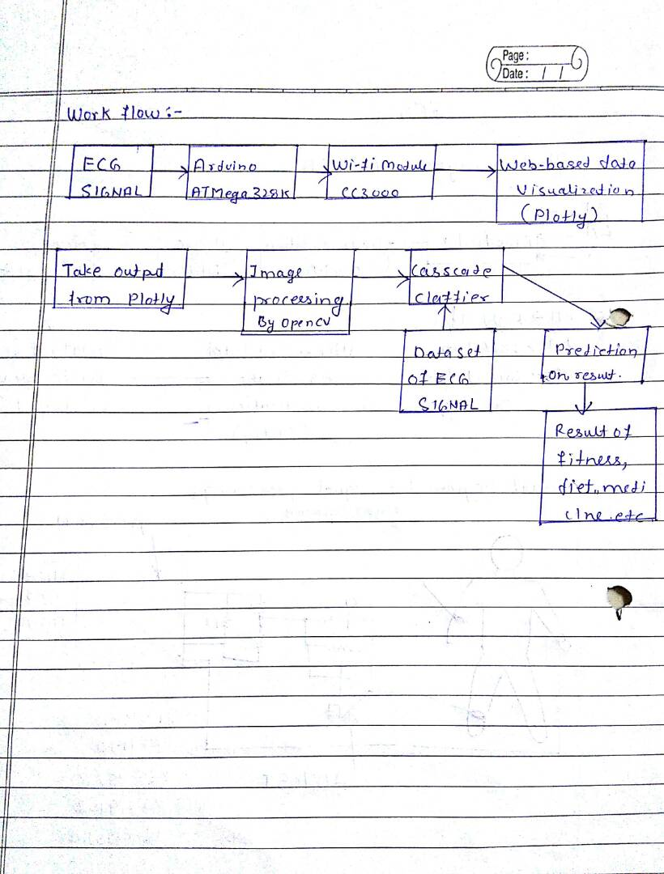

Apparatus: AD622 instrumentation amplifier,LM358 OPAMP.

Machine: Arduino duemilanove AT Mega 328k,adafruit cc3000 wi-fi breakout module.

Sensor:disposable agcl electrodes (3-lead configuration sensor)

Libraries: opencv librariy, cascade classifier,dataset .

References :
Wikipedia
Scientific Computing And Imaging Institute – University of Utah
AD620 Data Set

